Colorado Archaeological Society
2022 Annual Conference
October 22-23, 2022
Embassy Suites, Loveland, Colorado
CONFERENCE INFORMATION
Welcome to Northern Colorado!
The Northern Colorado Chapter of the Colorado Archaeological Society is pleased to host the 2022 CAS Annual Conference on October 22nd and 23rd!
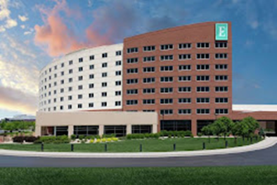
Conference Location and Room Reservations
The presentations, meetings, silent auction, Saturday evening banquet and keynote speaker will all be held at the Embassy Suites, 4705 Clydesdale Parkway, Loveland, Colorado, with an easily accessible location just off I-25. A small block of rooms has been booked at the special rate of $169+tax. For room reservations, call (970) 593-6200. If you prefer to stay at an alternative location, there are several options in the vicinity including the Holiday Inn Express, Candlewood Suites, Microtel Inn and Suites, My Place Hotel, and WoodSpring Suites. Please check the internet for availability, pricing, and reservations.
Registration
Registration is required to participate in all conference activities. For the lowest rate, please register before October 1st. Upon arrival to the conference, follow the signage to the registration table to pick up your name badge and welcome bag. On-site registration will be open beginning at 7:30 Saturday morning.
Meetings
The state CAS Board meeting will be held during the lunch hour and the quarterly CAS meeting will be in the late afternoon. Specific details on times and location will be available in mid-September.
Silent Auction and Book Sale
A silent auction and book sale will be held throughout Saturday with proceeds benefiting the Alice Hamilton scholarship Fund. Since the scholarship inception in 1987, CAS has distributed hundreds of awards, totaling over $100,000, to Colorado college and university students majoring in Anthropology/Archaeology!
Saturday Evening Social, Banquet, and Keynote Speaker
Join us for conversation, a cash bar, and time to reflect on the day’s archaeological topics followed by a delicious Tuscan buffet. The evening will conclude with a keynote address by the renowned Dr. Jason LaBelle speaking on the Roberts Ranch and archaeology sites in Northern Colorado.
Speakers
A great line-up of speakers is being arranged on a vast array of topics ranging from dendrochronology to rock art to pottery and much more. The speakers, topics, and schedule will be announced and posted in mid-September as we finalize details.
Check back periodically as we add information on tours, sponsors, and more!

